Supplementary Document

Zhaoyang Gu

STAT617

11/2/2020

**Figures:**

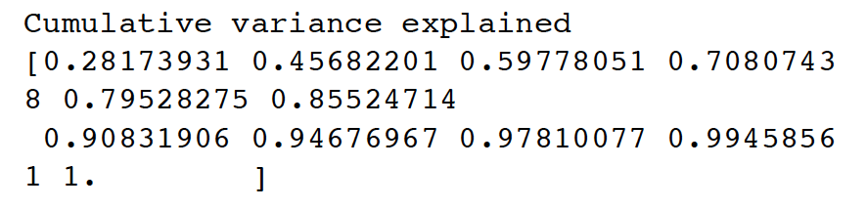

**Figure 1. Cumulative variance explained by principle components**

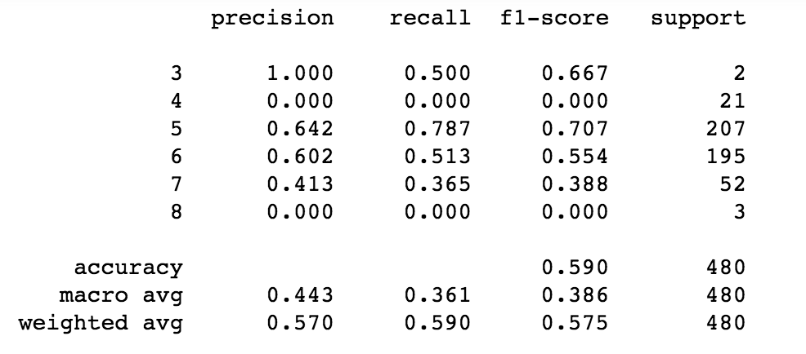

**Figure 2. report of QDA classification on original quality scores**

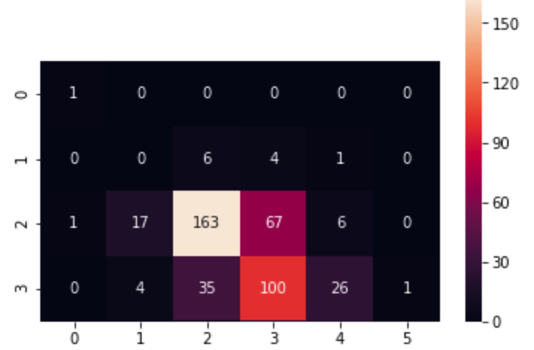

**Figure 3. Confusion matrix of QDA classification on original quality scores**

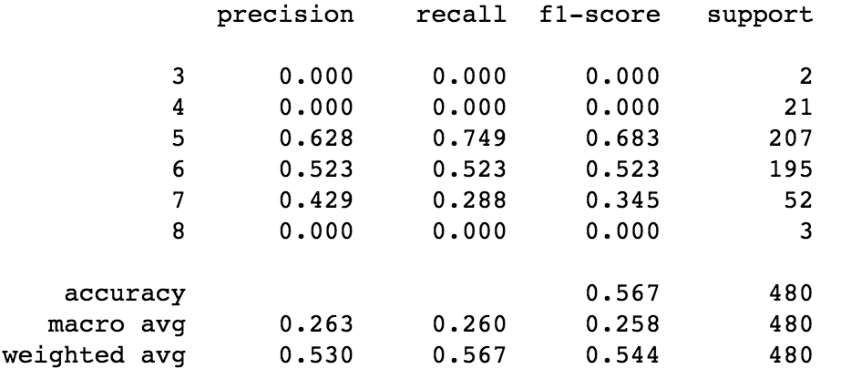

**Figure 4. report of LDA classification on original quality scores**

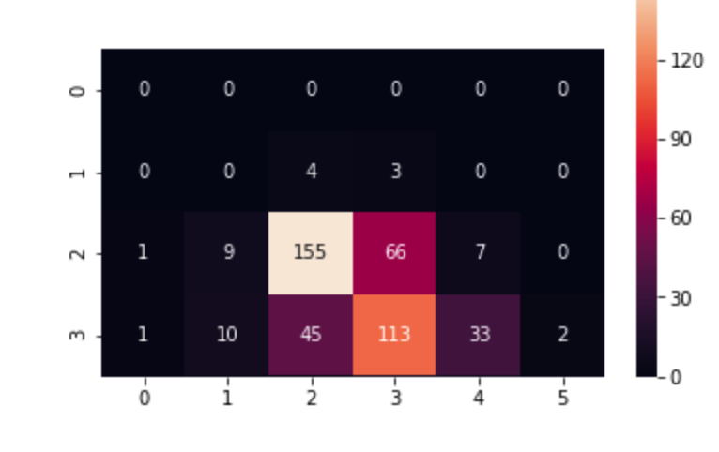

**Figure 5. Confusion matrix of LDA classification on original quality scores**

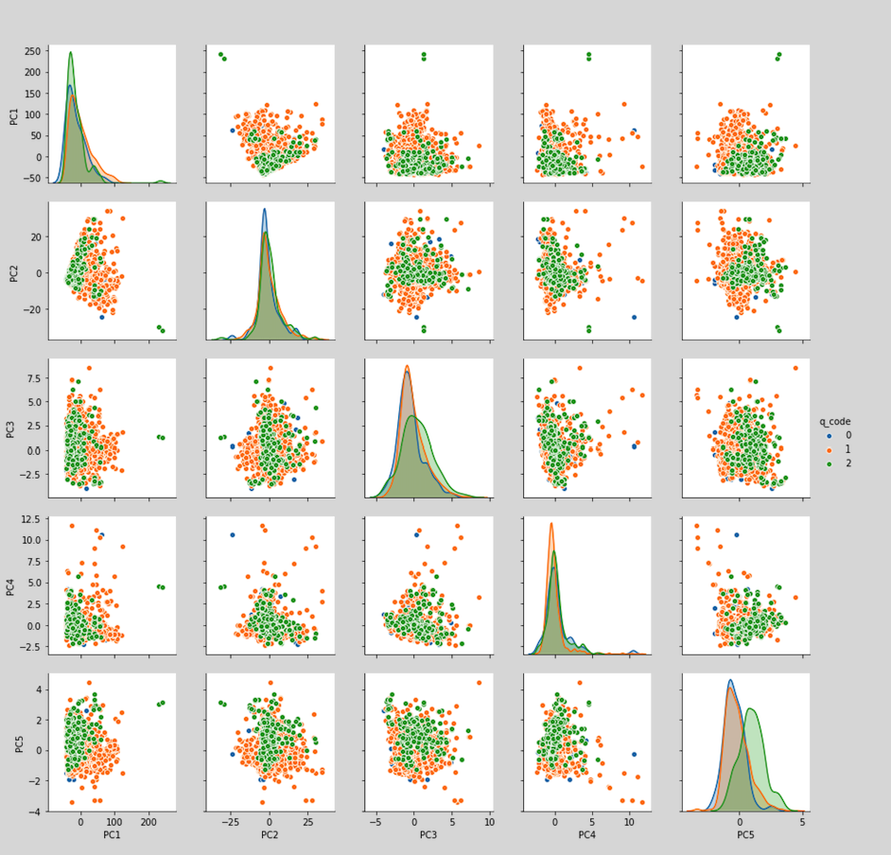

**Figure 6. Pair plots after re-coding the quality variable**